Unit Two: The European Union

Aims: Introducing the European Union to pupils.
Learning about the countries in the EU: maps, languages, cultures and flags.
Learning facts about the EU and what makes each country special.

The aim of this session is to teach children about the European Union. You can use the activities selectively or spread them out to a longer period in the school-year. Most of them are for younger pupils and involve some arts and crafts (1-3). The last section (4) is for older and more advanced pupils.

Materials: printed blind map
paper
colour pencils /markers
long piece of string
glue
souvenirs from holidays in EU countries
kahoot.com
the applications mentioned in the activity descriptions

Warmer: Hi Five! Game (I know someone who …, I’ve been to ….):
  - Culture, languages, personalities, appearance, special needs are explored with the game and then progress with the game to WIN.
  - This is an active, fun way to explore and celebrate the rich diversity of experiences that different people bring to any group. Works best with larger groups.
  - The instructor explains that he/she will call out different things that may or may not apply to each person. If the item does apply to you, then run into the middle, jump in the air, and do a high 5 with anyone else who runs in.
  - Possible questions (for adults and/or children)
  - Can you speak 2 or more languages?
  - Have you visited more than 3 different countries?
  - Do you have both a brother and a sister?
  - Do you have a pet at home?
  - Have you ever climbed to the highest point in your city or town?
  - Have you ever sung karaoke?
  - Have you ever ridden a horse?
  - Have you ever eaten frogs' legs?
  - Do you have a relative or a friend who is a vegetarian?
  - Have you swum in a river?
  - Have you ever had a close relative who lived to over 80?
  - Have you ever been on a boat trip?

- EU Countries on the map:
- Ask your pupils to list your neighbouring countries
- Ask the pupils to name and colour them on this blind map of Europe. (If you live on another continent, name and colour five European countries).
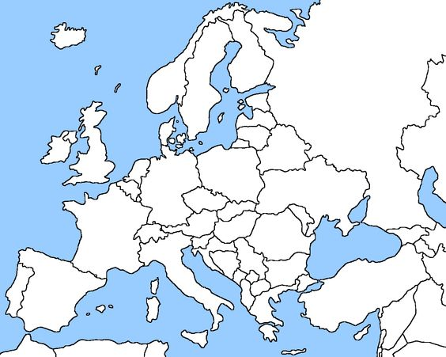
Source: https://freeworldmaps.net/printable/europe/

- Do your pupils recognise European countries by their shape? Play this online puzzle game with them: they have to recognise, drag and match the countries in the map. https://europa.eu/learning-corner/eu-puzzle_en
(This is the ‘Easy’ version of the EU Puzzle.)

- Languages and cultures:

- Greetings:
a) Hello! Hola! Ciao! Szia! Do you know how to greet each other in other languages?
b) Ask you your pupils in how many languages they can greet someone. Write them on the board.
c) In the following game pupils need to match the greetings in different languages with the country where they are used. All of the countries are in the European Union.
https://europa.eu/learning-corner/eu-puzzle_en
(This is the ‘Difficult’ version of the EU Puzzle.)

- Show-and-tell: souvenirs
a) If you have any typical souvenirs from European countries (e.g. a keychain with a small Eiffel Tower from Paris, a fan from Spain etc.) bring one into class and encourage your pupils to guess where it is from.
b) Ask your pupils to bring in souvenirs from home and let them present these objects in ‘show-and-tell’ sessions.
c) Let them play the ‘Guess the gifts with Grandma’ game. Here they can guess the souvenirs the children brought from holiday with the help of ‘join-the-dots’ games.
https://europa.eu/learning-corner/guess-the-gifts-with-grandma_en
Read the short explanation about each gift.

- Landmarks:
a) Share pictures of a number of typical European landmarks. Play a game of Kahoot! with these photos to help your pupils to find out where they can be found.
b) Let your pupils play the ‘Match the Landmark’ online memory game.
https://europa.eu/learning-corner/match-the-landmarks_en

- Flags:
- Ask your children to look at the colourful map at the beginning of this Moodle session (can be downloaded at: https://op.europa.eu/en/publication-detail/-/publication/034b43d5-40e3-11eb-b27b-01aa75ed71a1/language-en)
- Tell them they can choose their favourite flag. They can draw and colour this flag.
You can help them by distributing these free colouring pages:
https://op.europa.eu/en/publication-detail/-/publication/5a6818ae-850a-11ea-bf12-01aa75ed71a1/language-en
- Create a bunting from the paper flags by attaching them on a string. Use it for decorating the classroom.
- Now play the online matching game with the 27 flags.
https://europa.eu/learning-corner/match-the-flags_en

- The EU: What’s it about? (for older pupils, aged 11-14 and whose English is at level A2-B1)
- The following reader contains information about each member country of the EU:
https://europa.eu/kids-corner/games-brexit/eu-whats-it-about/pdf/EU-Whats-it-about_en.pdf
- Choose one country you are going to read about together with your pupils. Your pupils can vote about which one to pick.
- Pre-reading: When you have picked a country make a pre-reading quiz about the country presentation in the online reader.
- Let your pupils first guess the answers, then find them in the text.
- Read the text together as a class.
- Ask pairs of pupils to work on a country of their choice: they read the country introduction and make a short trivia quiz for the rest of the class.
- Play the ‘Find the hidden facts’ game online:
https://europa.eu/learning-corner/the-eu-whats-it-all-about_en

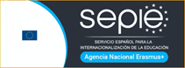

The project Writing for Inclusion (2020-1-ES01-KA201-081827) has been funded with support from the European Commission. This document reflects the views only of the author, and the Commission cannot be held responsible for any use which may be made of the information contained therein.

