Unit 3: eTwinning

Aims: Introducing and explaining e-twinning.
Learning about international big or small-scale projects.
Getting to know each other.
Learning how to communicate respectfully with each other.
Raising awareness of the value of collaboration.

Materials: ‘All about me’ worksheets and templates.
Informational video clips.
Inspirational video clips.
Platforms and applications (e.g. Mentimeter.com, Adobe.com, YouTube, Teams,
Stormboard)
Paper and markers (posters, worksheets).

Lesson 1: Introducing yourself to others

Aims: Raising awareness of who you are and what is important for you.
Learning about each other (facts, favourite things).
Identifying categories and topics that may characterise a person.
Creating an informative poster or a PPT and sharing it with others.

Materials: “All about me” worksheets and templates. https://www.adobe.com/express/create/worksheet/all-about-me
Big sheets of wrapping paper with thick markers.
Online platforms and applications (e.g. Teams, Stormboard, Adobe)

Warmer: ‘Two truths and a lie’ game.
Participants say three sentences about themselves and others guess which one is not true.

Asynchronous online version: using post-it notes and leaving comments on a collaboration platform (e.g. Teams whiteboard, Stormboard, etc.) to identify the true facts and the lies.

Main Task: Creating ‘All about me’ posters

Lead-in: Brainstorming topics and interests that may characterise a person using the word: FAVOURITE

- favourite food
- favourite number
- favourite school subject
- favourite song
- favourite movie
- favourite country
- favourite sport
- favourite language
- favourite author
- favourite ice cream flavour
- favourite story character
- favourite book
Task (a): Filling in the ‘All about me’ worksheet or template (online or offline).
Individual work: See templates attached.

Pupils select designs they like and fill it in with age-relevant information about themselves.
- name
- nickname
- favourite holiday
- dream job
- where I’m from
- in my free time I like to
- any pets? its name?
- favourite music
- secret talent, special talent
- favourite season
- biggest achievements
- (plus others, see in the lead-in)

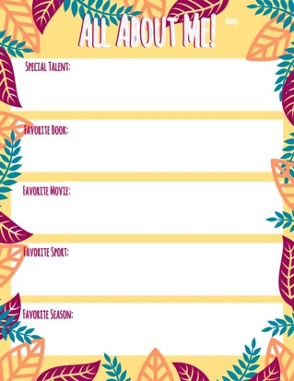

Task (b): Survey and discussion. Asking and answering about favourite things and other facts.

Pupils walk around and talk to each other showing their posters. They may look for peers with the same template, with similar interests and shared “favourite things” or search for differences. They are also asked to find out exciting new facts about each other.

Follow-up: Creating a poster which shows facts about the whole class or group.
Pupils create a poster using wrapping paper that introduces their class or group, then share it with a selected partner group from the school.

Online version: creating a PPT introducing their class or group and sending it via email.



The project Writing for Inclusion (2020-1-ES01-KA201-081827) has been funded with support from the European Commission. This document reflects the views only of the author, and the Commission cannot be held responsible for any use which may be made of the information contained therein.

