Unit 3: eTwinning

Aims: Introducing and explaining e-twinning.
Learning about international big or small-scale projects.
Getting to know each other.
Learning how to communicate respectfully with each other.
Raising awareness of the value of collaboration.

Materials: ‘All about me’ worksheets and templates.
Informational video clips.
Inspirational video clips.
Platforms and applications (e.g. Mentimeter, Adobe.com, YouTube, Teams, Stormboard)
Paper and markers (posters, worksheets).

Lessons 2 and 3: eTwinning projects: small and big

Aims: Introducing and explaining eTwinning.
Learning about big international and small-scale projects.
Raising awareness of the value of collaboration.

Materials: Informational video clips.
Inspirational video clips.
Song (‘Let it go’ sung in multiple languages)
A map with country names.
Logo (eTwinning)
Online platforms and applications (e.g. Mentimeter)

Warmer: Brainstorming names of nationalities and/or languages. Finding countries on a map.

Inspiration: The multilingual “Frozen” song sung in multiple languages.
Topic: diversity and unity, working together to achieve something great, being different and making a beautiful whole.

Song: Let it go – this version is good for all age groups.
(The real singers can be seen, the languages are written on the screen, and scenes from the original movie are also included in the YouTube video clip)

https://www.youtube.com/watch?v=BS0T8Cd4UhA

- Pre-viewing: Guess the number of languages appearing in this video. Predict the languages you will hear.
- While-viewing: Check your predictions. Count the different languages used.
- Post-viewing: Memory game. Recall as many languages as you can.
- What is common in the singers?

Lead-in: The eTwinning logo and animation videos: Association game and learning about eTwinning

The logo

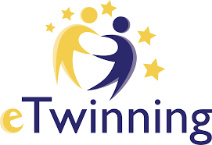

Animation videos
short ones (for children):
https://www.youtube.com/watch?v=b9MqoVPH048
https://www.youtube.com/watch?v=Fj58uA4cjrQ

longer ones (for adults):
https://www.youtube.com/watch?v=1TqVkhlfS00 (The concept and the benefits of eTwinning Schools)
https://www.youtube.com/watch?v=3_wxh9SPp9k (Friends of eTwinning)
https://www.youtube.com/watch?v=4VQMNOYe2VA (a new project announcement: 2021 Spring)

Main Task (1): Learning about e-twinning projects: small

Small: ‘Promoting your city’ (a current small-scale eTwinning project with 29 subscribers)
Visiting the website.
https://www.youtube.com/channel/UCs6XoZA2pbiW3O2ILvRvCdQ?app=desktop
Checking some short videos (not all of them are in English!)

Main Task (2): Learning about e-twinning projects: big

source: original video (1.5 hrs)
https://www.youtube.com/watch?v=_K9HkxgTrxE&t=2929s
Classroom in action: Addressing climate change with eTwinning
Data: Climate Action Project: 1 project, 130 countries, 10 million students, since 2017

Viewing: shortened version (10 mins)
https://drive.google.com/file/d/1S3qMgWu5HW3acvkwfXlubNvEnXhEF9IL/view?usp=sharing (online-video-cutter.com)

Pre-viewing: Mentimeter.com – a word cloud – the topic is ‘Climate Change’ – asking for associations
Photo used (taken from the video):

or 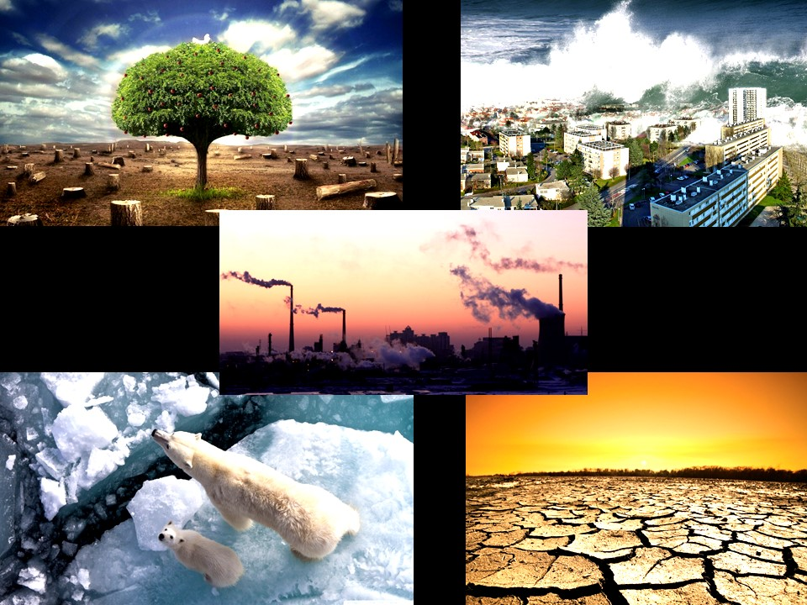

While-viewing: Counting the number of countries mentioned and remembering their names.
Watching again and checking the answers.

https://drive.google.com/file/d/1S3qMgWu5HW3acvkwfXlubNvEnXhEF9IL/view?usp=sharing

Post-viewing: Recalling participating students’ achievements
(2 examples shown in the pictures below: big and small)

Follow up: Checking the Mentimeter vote and adding some extra answers (what they have
learnt)
Discussion: GW: What would your class do to prevent climate change?
Collect ideas: small or big.

Link to WIN and Session 4: A middle-sized eTwinning project
eTwinning 2019 winning project: Storytelling leads to robotics (young learners)
https://www.youtube.com/watch?v=1ugoltrnUoI



The project Writing for Inclusion (2020-1-ES01-KA201-081827) has been funded with support from the European Commission. This document reflects the views only of the author, and the Commission cannot be held responsible for any use which may be made of the information contained therein.

