Unit Nine: Creating a plot

Aims: Creating a story plot
Choosing between narrative structures
Applying previously used skills, such as creating characters, settings etc.
Practising online story generators

Materials: sets of Story Cubes (commercially available or made together with your pupils)
https://www.storyboardthat.com/comic-maker(or any other digital comic strip maker)
https://www.plot-generator.org.uk/
https://www.plot-generator.org.uk/story/
https://www.plot-generator.org.uk/fairytale/

Warmer: Pupils form groups of 3-4 and play with Story Cubes. They create stories with the
help of the images on the cubes. (If you cannot get hold of this game, you can create
the story cubes together with your pupils: make cubes and draw random images of the children’s choice on their sides. Use sets of four cubes.)
Let the pupils share their stories with other groups.

Lead-in: Discussion with pupils:
Did you like your stories?
Could you make them more interesting and engaging?
Revise how to create:
- settings
- characters
- dialogues
Let them modify their stories.
Introduce the idea of plot.

Activities:

1) The Story Mountain: a) Relying on The Usborne Write Your Own Story Book, draw a mountain and a little
stick figure on the board. The stick figure represents your main character in the story.

b) Explain how the figure has to climb the mountain.

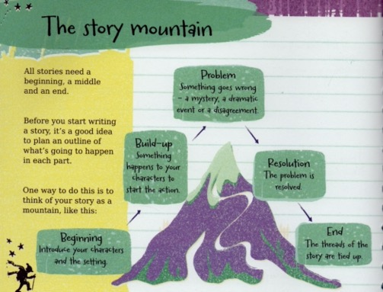
(from: Stowell, L. (2011). The Usborne Write Your Own Story Book. London: Usborne)

c) The stages of the mountain climb are the following:
      - Beginning: characters and setting.
      - Build-up: Something happens to your character, which starts the action: a mystery, a dramatic event or a disagreement.
      - Resolution: the problem is solved.
      - End: the threads of the story are tied up.
- Ask your pupils to look at some fairy tales and identify the problem and solution in them: Cinderella, Goldilocks, Rapunzel etc.

2) Four-sentence story: Plan a simple four-sentence story with your pupils.
Once upon a time there was …
One day he/she …
So, he/she …
In the end, …
Optional: create a group of characters, settings, adjectives, parts of dialogues etc. in advance and let your pupils use those words for the story creation.

3) Using story generators: Explain to your students how a story-generator works, i.e. if they feed in the
data required for a story the generator is going to compile a story for them. Let the
pupils explore a generator.

https://www.plot-generator.org.uk/

And here is one for plots and one for fairy tales:

https://www.plot-generator.org.uk/story/
https://www.plot-generator.org.uk/fairytale/

4) Conclusion: Choose the best story (or stories) and ask your pupils to draw some pictures as
illustration.



The project Writing for Inclusion (2020-1-ES01-KA201-081827) has been funded with support from the European Commission. This document reflects the views only of the author, and the Commission cannot be held responsible for any use which may be made of the information contained therein.

