Unit Eight: Diversity and creativity

Aims: Raising awareness of differences.
Accepting and respecting diversity.
Fighting against stereotypes.
Learning about and supporting diversity.
Developing creativity.

Materials: Worksheets: Metaphor grid, Human Diversity Bingo.
Wrapping paper and markers or smart devices.
Inspirational video clips and images.
Applications: Mentimeter, Kahoot, Bingo creator, Power Point, YouTube.

Lesson 1: Creating metaphors

Aims: Raising awareness of diversity.
Learning about being special and unique.
Creating metaphors and posters.

Materials: Application: mentimeter.com.
Sheets of paper and markers.
Worksheet: Metaphor grid.

Warmer: Drawing task: What would you be if you were a plant / an animal / a natural phenomenon?
Collecting all the pictures and play a guessing game.
Discussion.

or:
Game: Find someone who...
Class survey. Make a chart. Write ’Find someone who ...’ on top of the chart. Each box should contain a different ending for the sentence and pupils should write in the name of another pupils whom the statement describes.
Some examples:
Find someone...
- who speaks more than 3 languages
- who is left-handed
- who knows sign language
- who has freckles
- who is wearing an interesting piece of jewellery
- who has a friend of another culture/race
- who is a vegetarian
- who can define multiculturalism
- whose name was anglicized
- who speaks English as a second language
- who likes sushi
- who is wearing something unusual
- who is a night owl
- who plays with Minecraft/FIFA/Fortnite
- who knows what Rocket League is
- who speaks the most languages
- who lives the longest distance away
- who knows the capital city of ...
- who was born in another country
- who has swum in a sea
- who has visited more than 10 countries
- who has the birthday in the same month as you
- who knows what inclusion means

Lead-in: Creating a wordcloud with Mentimeter on a specific topic connected to diversity. E.g. bilingualism, multilingualism. What comes to your mind…? Collecting associations.
Example:

Task: Metaphors and Diversity

- Creating metaphors. Use sensitive issues connected to diversity (see the list below for ideas). Finish the sentences. Share your ideas and discuss similarities and differences.

- Being bilingual in a monolingual classroom is like a … because …
- Inclusion is like a …. because ….
- Being bullied is like ….
- Being fat among skinny kids…
- Wearing a ….
- Believing in ….
- Being the only one who …
- Dyslexia is like …
- Poverty is like …
- A child with special needs might feel like … among the others …
- …

- Selecting ONE topic and creating metaphors. Work in pairs. Use the metaphor grid.
What or who would it be if…? Share your ideas with the others.

Lesson 2: Playing and creating a diversity Bingo

Aims: Raising awareness of diversity.
Fighting against stereotypes.
Learning about different topics connected to diversity.

Materials: Worksheet: Diversity bingo cards.
Application: Buzz-buzz bingo creator.

Warmer: Play Diversity Human Bingo.
Two examples of Bingo cards.
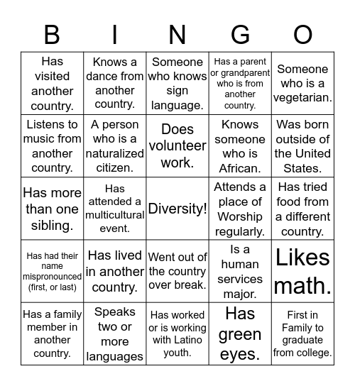

Task: Create your own bingo cards randomly using the application (24 items):
https://www.buzzbuzzbingo.com/customize/74576

Possible items: Born outside the USA, Have a friend of a different racial background, Have a friend whose personality is almost opposite your own, Have a friend with a major disability, Have an interracial family member, Have attended a religious ceremony in a church/temple/mosque other than your own, Have discussed racial issues with a friend of a different race, Have eaten Chinese food, Have eaten Korean food, Have eaten at a Thai restaurant, Have eaten food with your hands as the culture dictates, Have lived outside the USA for more than a month, Have traveled to Africa, Have traveled to Asia, Have traveled to Europe, Have traveled to South America, Have watched more than 2 movies with sub-titles, Have worked with someone born outside of the USA, Have worked with someone that has a major disability, Know a non-verbal gesture that translates differently in other cultures, Know about wedding customs in a country other than your own, Speak more than one language, Would categorize self as a perfectionist, Would categorize self as an extrovert.

Task: Create a diversity bingo card for your own context i.e. for young learners of your own class. Share it with other colleagues and reflect on each other’s bingo cards.

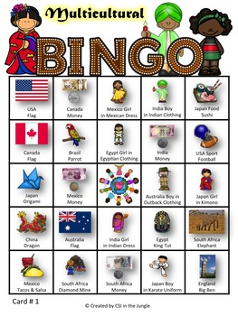

Lesson 3: Knowledge, creativity and promoting diversity

Aims: Raising awareness of diversity.
Fighting against stereotypes.
Learning about bilingualism.
Promoting diversity.
Developing creativity.

Materials: Wrapping paper and markers.
(a camera, a smart phone, a tablet, a laptop)
Application(s): Kahoot (game makers, YouTube and video making apps).

Warmer: Fact or Misbelief? True or False?
A Kahoot! quiz on common misbeliefs connected to bilingualism. Players can join this challenge up until the deadline (now it is 12 July) using the link or the game PIN below.

https://kahoot.it/challenge/08731103?challenge-id=12956392-d710-4151-946d-030b1ba47eb0_1623768434274
Game PIN: 08731103

Questions (20)
1 - True or false
Bilingualism is not a rare phenomenon.
20sec
2 - True or false
Bilingualism causes confusion.
20sec
3 - True or false
Monolingual parents can raise bilingual kids.
20sec
4 - True or false
Bilinguals are equally proficient in both languages.
20sec
5 - True or false
Bilinguals are not necessarily bicultural.
20sec
6 - True or false
Before the 1960's bilingualism was considered as a handicap.
20sec
7 - True or false
Children have to be smart to be bilingual.
20sec
8 - True or false
Children have to wait to know one language before learning another.
20sec
9 - True or false
Bilingual kids can learn multiple languages from birth.
20sec
10 - True or false
Bilinguals have double or split personalities.
20sec
11 - True or false
The brain can learn only one language at a time.
20sec
12 - True or false
Children raised bilingual will always mix their languages.
20sec
13 - True or false
Learning two languages will prevent either one from being learnt properly.
20sec
14 - True or false
Bilingual kids mix their languages, but it is normal.
20sec
15 - True or false
Mixing languages is a sign of confusion or laziness.
20sec
16 - True or false
Children with special needs can become bilingual.
20sec
17 - True or false
Bilingualism does not mean speaking with the perfect accent.
20sec
18 - True or false
Bilingual kids will fall behind in school.
20sec
19 - True or false
TV will make your child fluent in a language.
20sec
20 – Quiz: This is a great quiz

Task: Project work:
Making a poster (or: video, mindmap etc.) to promote diversity in a creative
way.
Choose a certain diversity topic (any issue).
Search for facts and creative materials (pictures, videos) on the chosen topic.
Create a poster in pairs or groups (or a PPT, an object, a game, a video etc).
Organise an exhibition and introduce the posters to each other. (It can also be a film club).
The examples: Being Bilingual – digital and hand-made creative works.
The first two posters are created by bilingualmonkeys.com.
The second one is a boardgame made by a Hungarian student teacher.

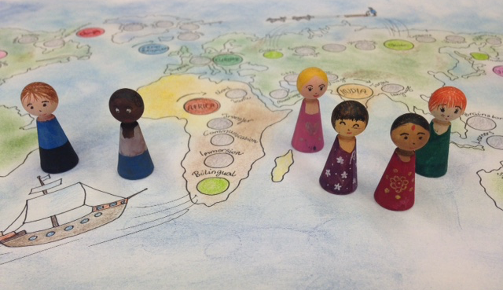

Rhyme: Acting out and reciting the following saying goodbye TPR rhyme (Total Physical Response). Pupils show the meaning of the various adjectives with movements, how big or small etc. they can be. At the end, everyone stands in a circle holding hands.

I’m big.
I’m small.
I’m tall.
I’m short.
I’m happy.
I’m sad.
I’m good.
I’m bad.
But we are FRIENDS,
and that’s THE END.

Extra task: Optional: Creative writing. It can be a homework task.
The rhyme can be rewritten to include more items referring to diversity.



The project Writing for Inclusion (2020-1-ES01-KA201-081827) has been funded with support from the European Commission. This document reflects the views only of the author, and the Commission cannot be held responsible for any use which may be made of the information contained therein.

